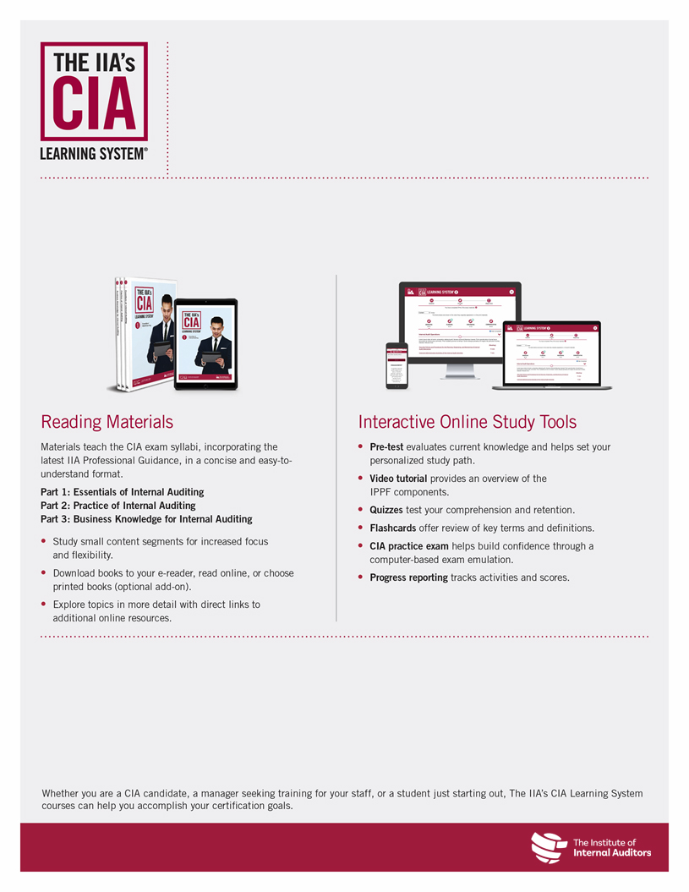

|  |  |  |
| --- | --- | --- |
| **Course** | **Schedule** | **Location** |
| **Part 1: Essentials of Internal Auditing** | <<Date/Time>> | <<Online/Physical Location>> |
| **Part 2: Practice of Internal Auditing** | <<Date/Time>> | <<Online/Physical Location>> |
| **Part 3: Business Knowledge for Internal Auditing** | <<Date/Time>> | <<Online/Physical Location>> |

4-Hour CIA Review Classes Coming <<Date>>!

**<< Chapter >>** will be offering short, 4-hour <<online/in-person>> CIA review classes starting <<Date>> using The IIA’s CIA Learning System. An expert instructor will lead you through an overview of the CIA exam syllabus, walk through practice questions, and providing test-taking tips to maximize your exam score.

**Prepare** to Pass the CIA Exam With <<Chapter>>

For more information or to register, please visit

<<URL>>.

Upcoming Course Dates

The following courses are available through <<Chapter>>: