

**Chapter Sponsored CIA Instructor-led Short Course Promotion**

**Get Unparalleled CIA Exam Prep with <<Chapter Name>>.**

**Enroll in Our <<Online/In-Person>> 4-Hour Courses.**

<<Chapter>>will be offering short, 4-hour <<online/in-person>> CIA® review classes starting <<Date>> using The IIA’s CIA Learning System®. An expert instructor will lead you through an overview of the CIA exam syllabus, walk through practice questions, and providing test-taking tips to maximize your exam score.

* Take advantage of the knowledge, experience and advice of our expert instructor, <<name, link to bio>>.
* Study the CIA exam syllabi and IPPF with The IIA’s CIA Learning System.
* Stay motivated and on track to achieving your CIA goal.
* Chapter members save on registration fees.

**Course Details**

**Dates/Times:**

* Part 1: <<Insert course dates/times>>
* 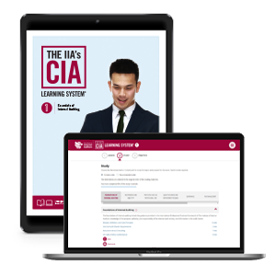Part 2: <<Insert course dates/times>>
* Part 3: <<Insert course dates/times>>

**Location:** <<provide location if using in-person format>>

**Instructor:** <<Insert instructor name, link to bio>>

**Fees:** <<Insert course fee>>

**Registration:** <<Registration URL>>

**Course Materials**

You will receive access to The IIA’s CIA Learning System®, Version 7.0 for all parts in which you enroll. Enjoy online reading materials with direct links to IIA resources, quizzes, flashcards, practice exam, and more. Get complete details at [www.LearnCIA.com](https://www.learncia.com/course-materials).

**Register now! (hyperlink to course URL) Classes fill quickly and space is limited.**

**For more information, please visit <<URL>>,**

**or contact <<name>> at <<phone>> or <<e-mail>>.**

**Social Media – Sample Posts**

**Facebook/LinkedIn/Instagram**

Preparing for the CIA exam? The IIA <Chapter> is offering an <in-person/online> 4-hour <Part 1/2/3> CIA exam review class on <Dates>.  Chapter members qualify for an exclusive discount. For details, contact <Number> or visit <Chapter URL>. #CIAExam #CertifiedInternalAuditor #TheIIA #CIACertification #AuditLife

**Twitter**

Preparing for the #CIAExam? Join #TheIIA <Chapter> for a 4-hour <Part 1/2/3> #CertifiedInternalAuditor exam <in-person/online> review class on <Date>. Get details at <Chapter URL>. #CIACertification #AuditLife